Dear all Partner,
As per Current guidelines from UIDAI, It is mandatory to register MFSTAB/MFS100 serial number with KYC detail for availing continue services after 31st July 2017. We must educate our channel partners/end-users on priority.
➔ User can directly visit our website servico.mantratecapp.com and complete the registration process using RD Service Mapping Tab.
➔ Fill all required details and save it.
➔ Mantra team will communicate person on registered Mobile number and guide them for further Process.

Kindly go through the below process of mapping your Mantra Device
First Open link http://servico.mantratecapp.com

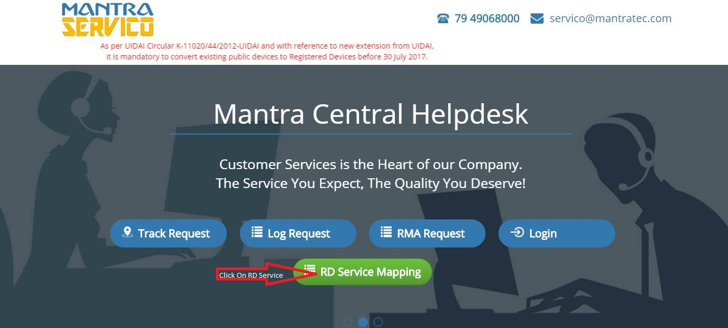
After the open link click on RD Service Mapping

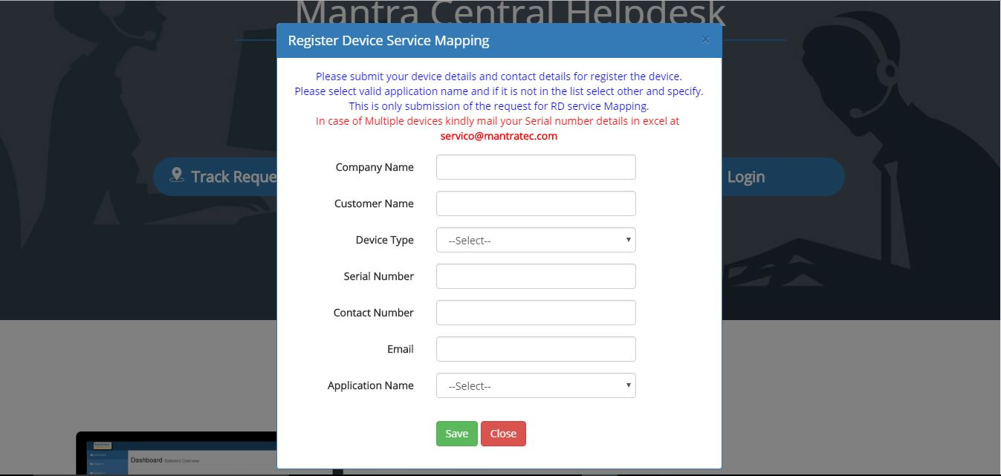
Fill every mention detail for Register Device Service Mapping
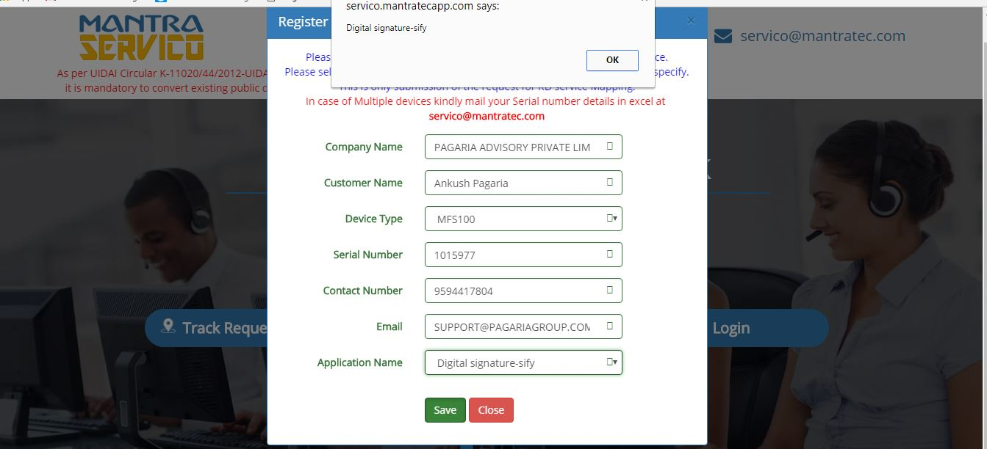
After click on Save Button your process has been completed.

http://servico.mantratecapp.com Support@pagariagroup.com

